Experiment No 2
Roll No:24141030 Lab: PL-II

Theory:
1. Introduction to Control Statements
Control statements in Python determine the flow of execution of a program. They allow decision making, looping, and branching based on conditions. Without control statements, programs would execute sequentially from top to bottom without any intelligence or repetition.
2. Types of Control Statements
Python provides three main types of control statements:
(A) Decision Making Statements (Conditional Statements)
These statements allow the program to make decisions and execute different blocks of code based on conditions.
if statement – Executes a block of code only if the condition evaluates to True.
Syntax:
if condition:
# code to execute if condition is True
if-else statement – Executes one block if condition is True, another block if False.
Syntax:
if condition:
# code if condition is True
else:
# code if condition is False
if-elif-else statement – Checks multiple conditions sequentially.
Syntax:
if condition1:
# code for condition1
elif condition2:
# code for condition2
else:
# code if no conditions are True
(B) Looping Statements (Iterative Statements)
Loops allow repeated execution of a block of code.
for loop – Iterates over a sequence (list, tuple, string, range, dictionary).
Syntax:
for variable in sequence:
# code to repeat
while loop – Repeats a block of code as long as the condition remains True.
Syntax:
while condition:
# code to repeat

(C) Jump Statements
These statements alter the normal flow of loops.
Statement | Description
break | Terminates the loop completely and exits
continue | Skips the current iteration and moves to the next
pass | Does nothing; acts as a placeholder

Programs and Code:
1. Program to check whether a number is even or odd
num = int(input("Enter a number: "))
if num % 2 == 0:
print(f"{num} is Even")
else:
print(f"{num} is Odd")
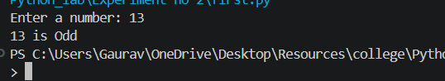
2. Program to find the largest of three numbers
a = float(input("Enter first number: "))
b = float(input("Enter second number: "))
c = float(input("Enter third number: "))
if a >= b and a >= c:
largest = a
elif b >= a and b >= c:
largest = b
else:
largest = c
print(f"The largest number is {largest}")
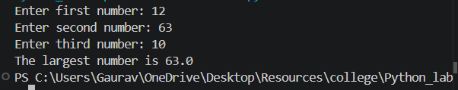
3. Program to check whether a year is leap year
year = int(input("Enter a year: "))
if (year % 4 == 0 and year % 100 != 0) or (year % 400 == 0):
print(f"{year} is a Leap Year")
else:
print(f"{year} is not a Leap Year")
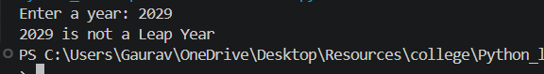
4. Program to check whether a number is prime
num = int(input("Enter a number: "))
if num <= 1:
print(f"{num} is not Prime")
else:
is_prime = True
for i in range(2, int(num ** 0.5) + 1):
if num % i == 0:
is_prime = False
break
if is_prime:
print(f"{num} is Prime")
else:
print(f"{num} is not Prime")
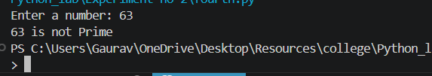
5. Program to print first n natural numbers using loop
n = int(input("Enter n: "))
print(f"First {n} natural numbers:")
for i in range(1, n + 1):
print(i, end=" ")
print()
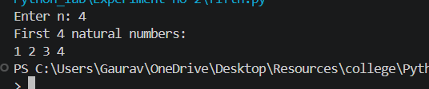
6. Program to print multiplication table of a given number
num = int(input("Enter a number: "))
print(f"Multiplication Table of {num}:")
for i in range(1, 11):
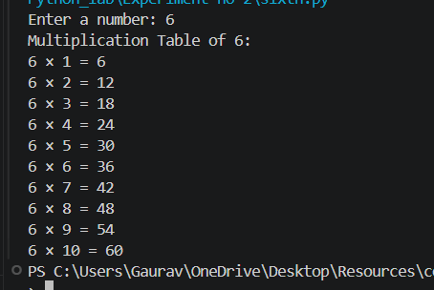
print(f"{num} × {i} = {num * i}")

7. Program to calculate factorial of a number using loop
num = int(input("Enter a number: "))
factorial = 1
for i in range(1, num + 1):
factorial *= i
print(f"Factorial of {num} is {factorial}")
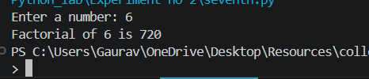
8. Program to display Fibonacci series
n = int(input("Enter number of terms: "))
a, b = 0, 1
print("Fibonacci Series:")
for i in range(n):
print(a, end=" ")
a, b = b, a + b
print()
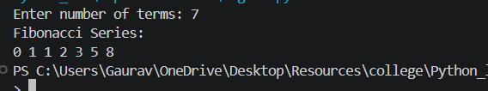
9. Program to count digits in a number
num = abs(int(input("Enter a number: ")))
count = 0
if num == 0:
count = 1
else:
while num > 0:
num //= 10
count += 1
print(f"Number of digits: {count}")
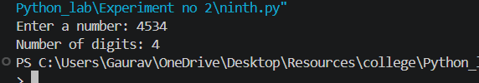
10. Program to reverse a number
num = int(input("Enter a number: "))
reverse = 0
temp = abs(num)
while temp > 0:
reverse = reverse * 10 + temp % 10
temp //= 10
if num < 0:
reverse = -reverse
print(f"Reversed number: {reverse}")
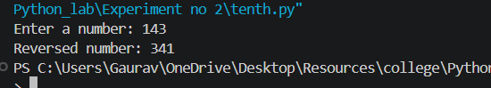

Conclusion
In this experiment, we studied control statements in Python including conditional statements (if, if-else, if-elif-else) and looping statements (for loop, while loop). We implemented various programs demonstrating decision making and iteration, which are essential for controlling program flow and creating intelligent, repetitive operations.

